RYTHIMIC TUNES(REACT)

(Music Streaming Application)

# Team ID: SWTID1741422090154388

**Team Leader:**

Ajay .A

[ajajay1431@gmail.com](mailto:ajajay1431@gmail.com)

# Team Members :

Melvin D Thomas

#### [melvindthomasxibs@gmail.com](mailto:melvindthomasxibs@gmail.com)

GokulaKrishnan M

[mt15gokul7@gmail.com](mailto:mt15gokul7@gmail.com)

Sathish D

[jokersathish052@gmail.com](mailto:jokersathish052@gmail.com)

## Introduction:-

Welcome to the future of musical indulgence – anunparalleledaudioexperienceawaits you with our cutting-edge Music Streaming Application, meticulously crafted using the power of React.js. Seamlessly blending innovation with user-centric design, our application is set to redefinehowyouinteractwithandimmerseyourselfintheworldof music.

Designed for the modern music enthusiast, our React-based Music Streaming Application offers a harmonious fusion of robust functionality and an intuitive user interface. From discovering the latest chart-toppers to rediscovering timeless classics, our platform ensures an all-encompassing musical journey tailored to your unique taste.

The heart of our Music Streaming Application lies in React, a dynamic and feature-rich JavaScript library. Immerse yourself in a visually stunning and interactive interface, where every click, scroll, and playlist creation feels like a musical revelation. Whether you're on a desktop, tablet, or smartphone, our responsive design ensures a consistent and enjoyable experience across all devices.

Say goodbye to the limitations of traditional music listening and welcome a world of possibilities with our React-based Music Streaming Application. Join us on this journeyas we transform the way you connect with and savor the universal language of music. Get ready to elevate your auditory experience – it's time to press play on a new era of music streaming.

## Scenario-BasedIntro:-

Imaginesteppingontoabustlingcitystreet,thesoundsofcarshonking,peoplechatting, and street performers playing in the background. You're on your way to work, and you need a little something to elevate your mood. You pull out your phone and open your favorite music streaming app, "RythimicTunes.

Withjustafewtaps,you'retransportedtoaworldofmusictailoredtoyourtastes.As you walk, the app’s smart playlist kicks in, starting with an upbeat pop song that gets your feet tapping. As you board the train, the music shifts to a relaxing indie track, perfectly matching your need to unwind during the commute.

## TargetAudience:-

MusicStreamingisdesignedforadiverseaudience,including:

* **MusicEnthusiasts:**PeoplepassionateaboutenjoyingandlisteningMusicThrough out there free time to relax themselves.

## ProjectGoalsandObjectives:-

The primary goal of Music Streaming is to provide a seamless platform for music enthusiasts, enjoying, and sharing diverse musical experiences. Our objectives include:

**User-Friendly Interface:** Develop an intuitive interface that allows users to effortlessly explore, save, and share their favorite music tracks and playlists.

**Comprehensive Music Streaming:** Provide robust features for organizing and managing music content, including advanced search options for easy discovery.

**Modern Tech Stack:** Harness cutting-edge web development technologies, such as React.js, to ensure an efficient and enjoyable user experience while navigating and interacting with the music streaming application.

# KeyFeatures:-

? **Song Listings:** Display a comprehensive list of available songswithdetailssuchas title, artist, genre, and release date.

? **PlaylistCreation:**Empoweruserstocreatepersonalizedplaylists,addingand organizing songs based on their preferences.

? **Playback Control:**Implement seamless playback control features, allowing users to play, pause, skip, and adjust volume during music playback.

? **Offline Listening:** Allow users to download songs for offline listening, enhancing the app's accessibility and convenience.

? **Search Functionality:** Implement a robust search feature for users to easily find specific songs, artists, or albums within the app.

## PRE-REQUISITES:-

HerearethekeyprerequisitesfordevelopingafrontendapplicationusingReact.js:

### ? Node.jsandnpm:

Node.js is a powerful JavaScript runtime environment that allows you to run JavaScript code on the local environment. It provides a scalable and efficient platform for building network applications.

InstallNode.jsandnpmonyourdevelopmentmachine,astheyarerequiredto run JavaScript on the server-side.

* + Download:<https://nodejs.org/en/download/>
  + Installationinstructions:<https://nodejs.org/en/download/package-manager/>

? **React.js**:

React.js is a popular JavaScript library for building user interfaces. It enables developers to create interactive and reusable UI components, making iteasierto build dynamic and responsive web applications.

InstallReact.js,aJavaScriptlibraryforbuildinguserinterfaces.

* + CreateanewReactapp:

npmcreatevite@latest

Enter and then type project-name and select preferred frameworks and then enter

* + Navigatetotheprojectdirectory:

cdproject-name npm install

* + RunningtheReactApp:

WiththeReactappcreated,youcannow start the development server and see your React application in action.

* + Startthedevelopmentserver:

npmrundev

Thiscommandlaunchesthedevelopmentserver,andyoucanaccessyourRe actappat[http://localhost:5173i](http://localhost:5173/)nyourwebbrowser.

?**HTML, CSS,andJavaScript**:BasicknowledgeofHTMLforcreatingthestructureof your app, CSS for styling, and JavaScript for client-side interactivity is essential.

?**Version Control**: Use Git for version control, enabling collaboration and tracking changes throughout the development process. PlatformslikeGitHuborBitbucket can host your repository.

* + - Git:Downloadandinstallationinstructionscanbefoundat: [https://git-](https://git-scm.com/downloads) [scm.com/downloads](https://git-scm.com/downloads)

?**Development Environment**: Choose a code editor or Integrated Development Environment (IDE) that suits your preferences, such as Visual Studio Code, Sublime Text, or WebStorm.

* + - VisualStudioCode:Downloadfrom<https://code.visualstudio.com/download>
    - SublimeText:Downloadfrom<https://www.sublimetext.com/download>
    - WebStorm:Downloadfrom<https://www.jetbrains.com/webstorm/download>

**Projectstructure:**

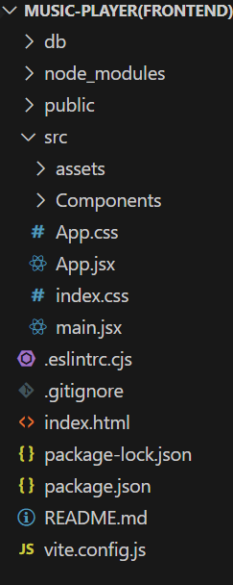

The project structure may vary depending on the specific library, framework, programming language, or development approach used. It's essential to organize the filesanddirectoriesinalogicalandconsistentmannertoimprovecodemaintainability and collaboration among developers.

app/app.component.css, src/app/app.component: These files are part of the main AppComponent,whichservesastherootcomponentfortheReactapp.Thecomponent handles the overall layout and includes the router outlet for loading different components based on the current route.

**PROJECTFLOW:-**

**Projectdemo:**

Beforestartingtoworkonthisproject,let’sseethedemo.

Demolink: [https://drive.google.com/file/d/1zZuq62lyYNV_k5uu0SFjoWa35UgQ4LA9/view?usp=drive_lin](https://drive.google.com/file/d/1zZuq62lyYNV_k5uu0SFjoWa35UgQ4LA9/view?usp=drive_link) [k](https://drive.google.com/file/d/1zZuq62lyYNV_k5uu0SFjoWa35UgQ4LA9/view?usp=drive_link)

Usethecode in: [https://drive.google.com/drive/folders/1BkYWfW_K3ek_UgtXNTAsDqlhdCuqz6nT?usp=drive](https://drive.google.com/drive/folders/1BkYWfW_K3ek_UgtXNTAsDqlhdCuqz6nT?usp=drive_link)

[_link](https://drive.google.com/drive/folders/1BkYWfW_K3ek_UgtXNTAsDqlhdCuqz6nT?usp=drive_link)

## Milestone1:ProjectSetupandConfiguration:

**1.Installrequiredtoolsandsoftware:**

### Installationofrequiredtools:

* 1. Opentheprojectfoldertoinstallnecessarytools In this project, we use:
     + ReactJs
     + ReactRouterDom
     + ReactIcons
     + Bootstrap/tailwindcss
     + Axios
* Forfurtherreference,usethefollowingresources
* <https://react.dev/learn/installation>
* <https://react-bootstrap-v4.netlify.app/getting-started/introduction/>
* <https://axios-http.com/docs/intro>
* <https://reactrouter.com/en/main/start/tutorial>

## Milestone2:ProjectDevelopment:

1. **SetupReactApplication:**
   * CreateReactapplication.
   * ConfigureRouting.
   * 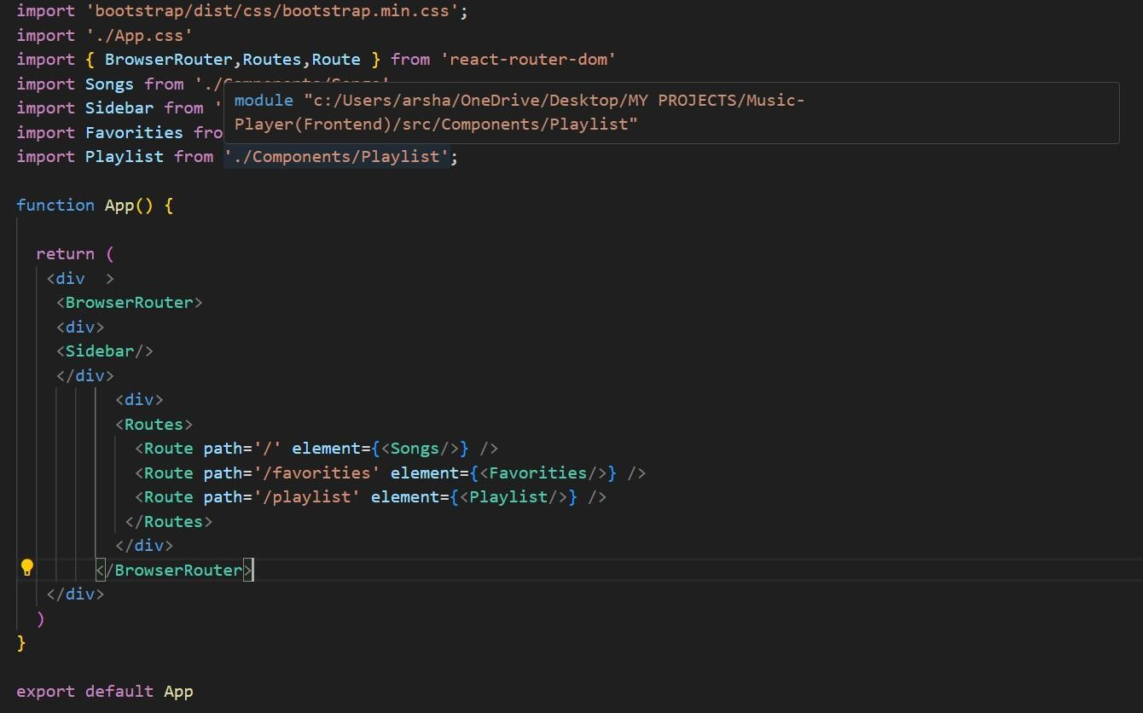Installrequiredlibraries. Setting Up Routes:-

**CodeDescription:-**

* + - Imports Bootstrap CSS (bootstrap/dist/css/bootstrap.min.css) for styling components.
    - ImportscustomCSS(./App.css)foradditionalstyling.
    - Imports BrowserRouter, Routes, and Route from react-router-dom for setting up client-side routing in the application.
    - Defines the App functional component that serves as the root component ofthe application.
    - UsesBrowserRouterastheroutercontainertoenableroutingfunctionality.
    - Includesadivastherootcontainerfortheapplication.
    - WithinBrowserRouter,wrapscomponentsinsidetwodivcontainers:
      * The first div contains the Sidebar component, likely serving navigation or additional content.
      * The second div contains the Routes component from React Router, which handles rendering components based on the current route.
      * InsideRoutes,definesseveralRoutecomponents:
        + Routewithpath='/'renderstheSongscomponent when the root path is accessed (/).
        + Routewithpath='/favorities'renderstheFavoritiescomponent when the /favorities path is accessed.
        + Routewithpath='/playlist'rendersthePlaylistcomponentwhenthe

/playlistpathisaccessed.

* + - Exports the App component as the default export, making it available for use in other parts of the application.

**FetchingSongs:-**

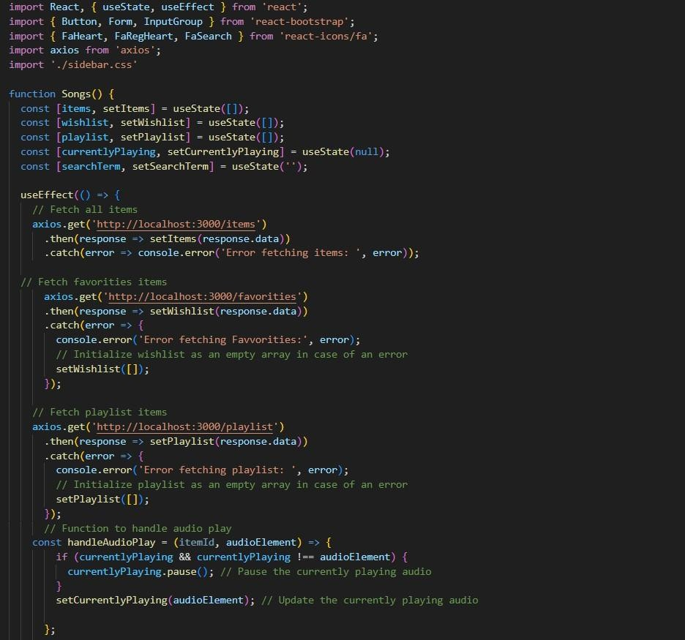

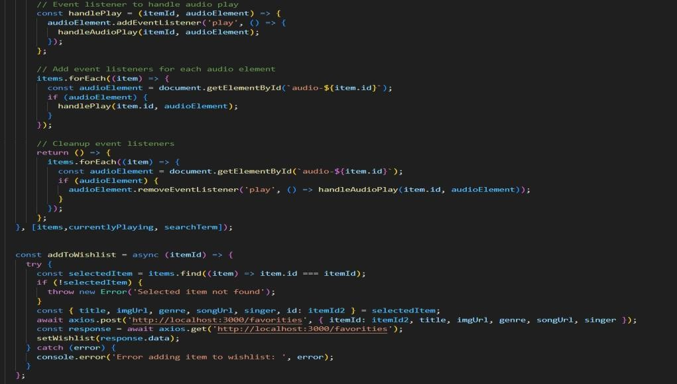

**CodeDescription:-**

* + - **useState:**
      * items:Holdsanarrayofallitemsfetchedfrom [http://localhost:3000/items.](http://localhost:3000/items)
      * wishlist:Storesitemsmarkedasfavoritesfetchedfrom [http://localhost:3000/favorities.](http://localhost:3000/favorities)
      * playlist:Storesitemsaddedtotheplaylistfetched from

[http://localhost:3000/playlist.](http://localhost:3000/playlist)

* + - * currentlyPlaying:Keepstrackofthecurrentlyplayingaudioelement.
      * searchTerm:Storesthecurrentsearchtermenteredbytheuser.
    - **DataFetching:**
      * UsesuseEffecttofetchdata:
* Fetchesallitems(items)from[http://localhost:3000/items.](http://localhost:3000/items)
* Fetchesfavoriteitems(wishlist)from

[http://localhost:3000/favorities.](http://localhost:3000/favorities)

* Fetchesplaylistitems(playlist)from

[http://localhost:3000/playlist.](http://localhost:3000/playlist)

* + - * Setsstatevariables(items,wishlist,playlist)basedonthefetched data.
    - **AudioPlayback Management:**
      * Setsupaudioplayeventlistenersandcleanupforeachitem:
* handleAudioPlay: Manages audio playback by pausing the currently playing audio when a new one starts.
* handlePlay:Addseventlistenerstoeachaudioelementtotrigger handleAudioPlay.
  + - * Ensuresthatonlyoneaudioelementplaysata time by pausing others when a new one starts playing.
    - **addToWishlist(itemId):**
      * Addsanitemtothewishlist(favorities)bymakingaPOSTrequestto

[http://localhost:3000/favorities.](http://localhost:3000/favorities)

* + - * Updatesthewishliststateafteraddinganitem.
    - **removeFromWishlist(itemId):**
      * Removes an item from the wishlist (favorities) by makingaDELETErequest to [http://localhost:3000/favorities/{itemId}](http://localhost:3000/favorities/).
      * Updatesthewishliststateafterremovinganitem.
    - **isItemInWishlist(itemId):**
      * Checksifanitemexistsinthewishlist(favorities)basedonitsitemId.
    - **addToPlaylist(itemId):**
      * Addsanitemtotheplaylist(playlist)bymakingaPOSTrequestto

[http://localhost:3000/playlist.](http://localhost:3000/playlist)

* + - * Updatestheplayliststateafteraddinganitem.
    - **removeFromPlaylist(itemId):**
      * Removesanitemfromtheplaylist(playlist)bymakingaDELETErequestto

[http://localhost:3000/playlist/{itemId}](http://localhost:3000/playlist/).

* + - * Updatestheplayliststateafterremovinganitem.
    - **isItemInPlaylist(itemId):**
      * Checksifanitemexistsintheplaylist(playlist)basedonitsitemId.
    - **filteredItems:**
      * FiltersitemsbasedonthesearchTerm.
      * Matches title, singer, or genrewith thelowercaseversionof

searchTerm.

* + - **JSX:**
      * Renders aformwithaninputfield(Form,InputGroup,Button,FaSearch) for searching items.
      * MapsoverfilteredItemstorendereachitemintheUI.
      * Includesbuttons(FaHeart,FaRegHeart)toadd/removeitemsfrom

wishlistand playlist.

* + - * Rendersaudioelementsforeachitemwithplay/pausefunctionality.
    - **ErrorHandling:**
      * Catchesandlogserrorsduringdatafetching(axios.get).
      * Handleserrorswhenadding/removingitemsfromwishlistandplaylist.

**FrontendCodeForDisplayingSongs:-**

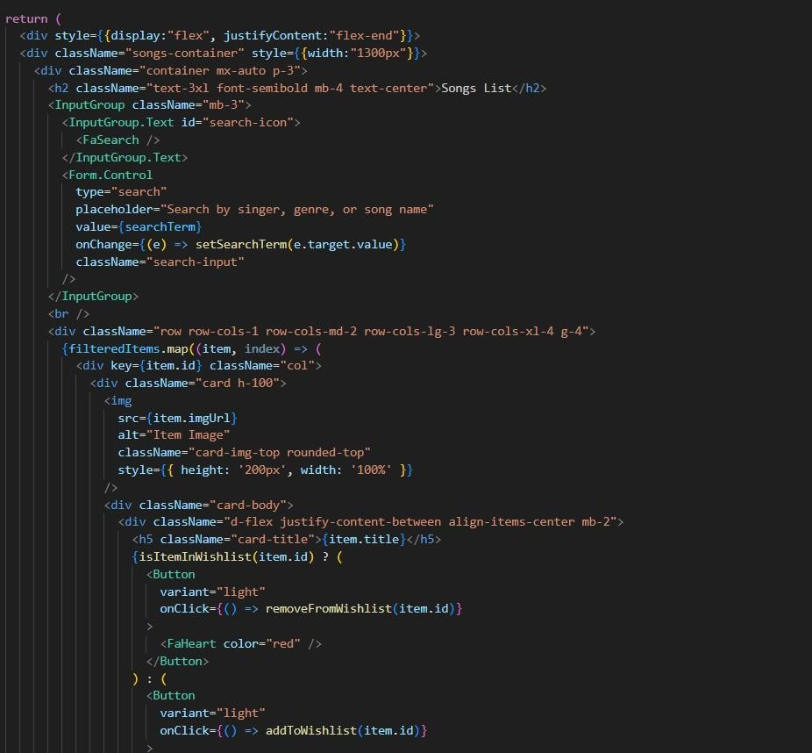

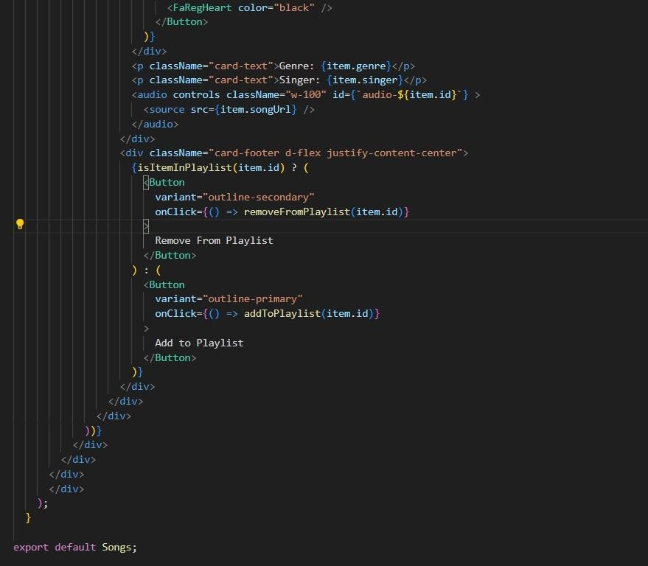

**CodeDescription:-**

* + - **ContainerSetup:**
      * Uses a divwith inline styles (style={{display:"flex", justifyContent:"flex-end"}})toalignthecontenttotheright.
      * The main container (songs-container) has a fixed width (width:"1300px")andcontainsalltheUIelementsrelatedtosongs.
    - **Header:**
      * Displays a heading (<h2>) with text "Songs List" centered (className="text-3xlfont-semiboldmb-4text-center").
    - **SearchInput:**
      * UtilizesInputGroupfromReactBootstrapforthesearchfunctionality.
      * Includesaninputfield(Form.Control)thatallowsuserstosearchbysinger, genre, or song name.
      * BindstheinputfieldvaluetosearchTermstate(value={searchTerm}) and updates it on change (onChange={(e)

=>setSearchTerm(e.target.value)}).

* + - * Styled with className="search-input".
    - **CardLayout:**
      * Uses Bootstrap grid classes (row, col) to create a responsive card layout (className="rowrow-cols-1row-cols-md-2row-cols-lg-3 row-cols-xl-4 g-4").
      * MapsoverfilteredItemsarrayandrenderseachitemasaBootstrapcard (<div className="card h-100">).
    - **CardContent:**
      * Displaystheitem'simage(<img>),title(<h5

className="card-title">),genre(<pclassName="card-text">), and singer (<p className="card-text">).

* + - * Includesanaudioplayer(<audiocontrolsclassName="w-100" id={audio-${item.id}}>) for playing the song with a source (<source src={item.songUrl} />).
    - **WishlistandPlaylistButtons:**
      * Addsahearticonbutton(<Button>)toaddorremoveitemsfromthewishlist (isItemInWishlist(item.id)determines which button to show).
      * Includesan"AddtoPlaylist"or"RemoveFromPlaylist"button(<Button>) based on whether the item is already in the playlist (isItemInPlaylist(item.id)).
    - **ButtonClickHandlers:**
      * Handles adding/removing items from the wishlist (addToWishlist(item.id),removeFromWishlist(item.id)).
      * Manages adding/removing items from the playlist (addToPlaylist(item.id),removeFromPlaylist(item.id)).
    - **CardStyling:**
      * AppliesBootstrapclasses(card,card-body,card-footer)forstylingthe card components.
      * Usescustomstyles(rounded-top,w-100)forspecificelementslikeimages and audio players.

## ProjectExecution:

Aftercompletingthecode,runthereactapplicationbyusingthecommand“npmstart”or “npm run dev” if you are using vite.js

And the Open new Terminal type this command “json-server --watch./db/db.json” to start the json server too.

AfterthatlaunchtheRythimicTunes. Herearesomeofthescreenshotsoftheapplication.

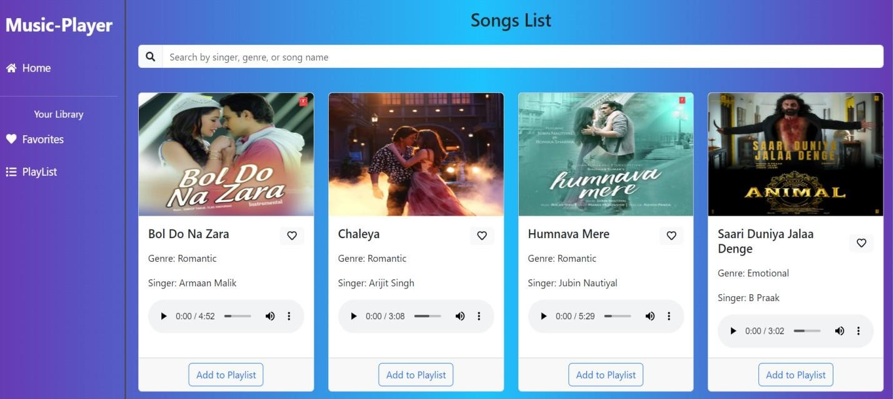**? Herocomponents**

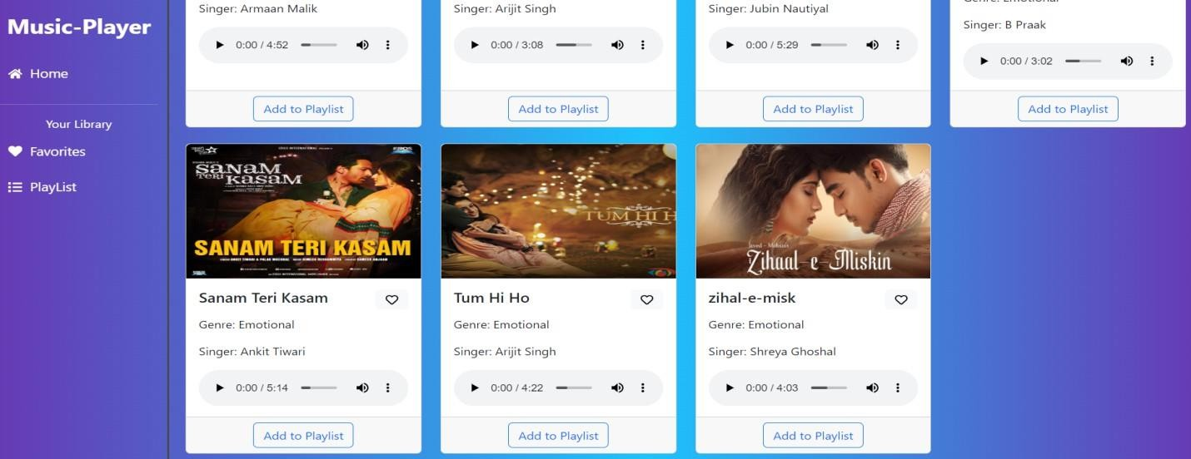

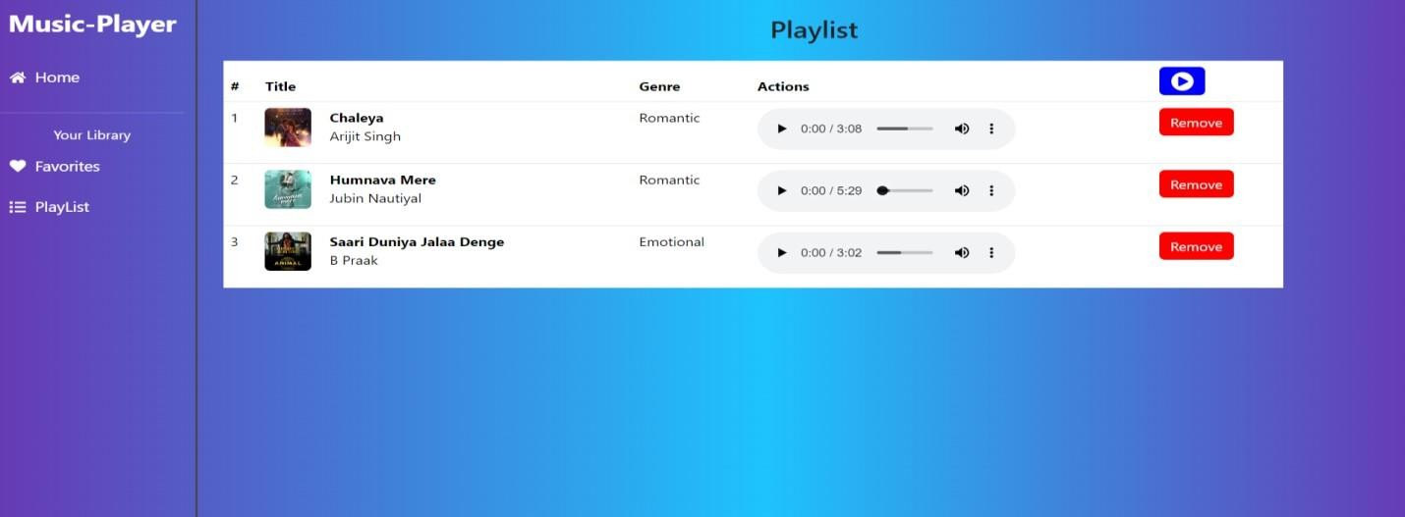**? Playlist**

**? Favorites**

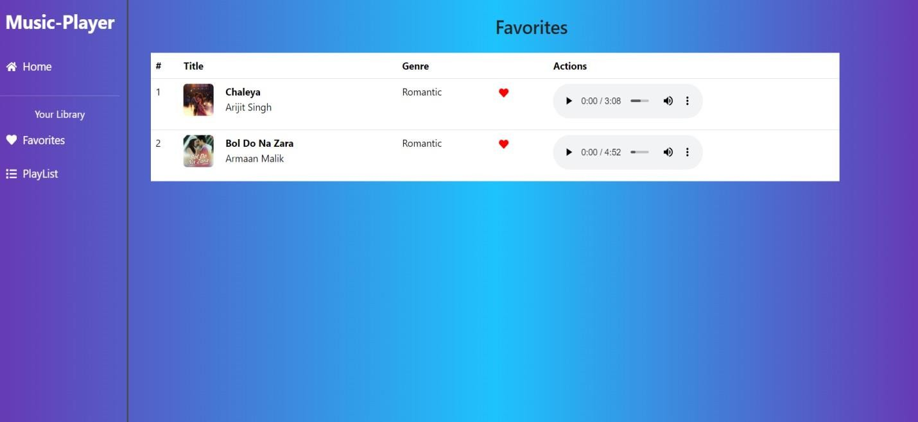

## ProjectDemolink:

<https://drive.google.com/file/d/1zZuq62lyYNV_k5uu0SFjoWa35UgQ4LA9/view?usp=drive_link>

**\*\*\* Happy coding!! \*\*\***